|  |
| --- |
| **Process Report ViaFit** |

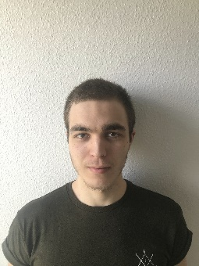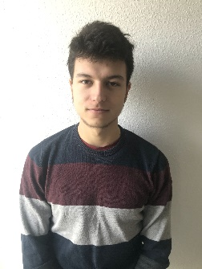

Mihail Alexandru Teodosiu

299111

Michal Pupák, 299128

Tamás Péter, 299124

**Supervisors**:Mona Wendel Andersen, Allan Rune Henriksen

**VIA University College**



**[Number of characters]**

**Software Engineering**

**Semester 1**

**[Date]**

**Table of content**

1 Introduction 4

2 Group Description 5

2.1 Culture 5

2.2 Group Roles 7

2.3 Project Experience Prior to Project Start 8

3 Project Initiation 9

3.1 Group Formation 9

3.2 Case Presentation 10

4 Project Description 10

5 Project Execution 13

5.1 Methods 13

5.2 Project Results 13

6 Personal Reflection 14

6.1 Péter, Tamás 14

6.2 Pupák, Michal 15

6.3 Teodosiu, Mihail Alexandru 15

7 Supervision 15

8 Conclusion 16

# Introduction

This semester project was completed by a group that was initially four members large. One member unfortunately dropped out of the program due to health issues. As a group we met about once a week to work on our semester project. During the quarantine, we met through Discord and in person. We did not meet on Wednesdays only; we were very flexible in that regard. During the semester we each worked approximately 7 hours per week on the project during the regular semester and over 50 hours per week during the final two weeks. Because of the loss of one group member it is difficult to calculate how many hours we worked, but we estimate that we collectively spent a total of 650-700 hours on the project.

Time was spent on analyzing the problem, communicating amongst ourselves, communicating with our supervisors, planning, coding, testing and documenting our work.

The work tools used for design were Astah, Balsamic and SceneBuilder. For coding, we used Intellij and for sharing folders we used GitHub and Google Drive. Finally, communication was made through Discord and Facebook.

# Group Description

Our group is constituted of members from diverse cultural backgrounds and personality profiles. Understanding the cultural backgrounds and the different personality traits of each member can give us a better understanding on how to effectively work as a team.

## Culture

**Hofstede Scores**

Our team is constituted of one Hungarian (Tamás), one Romanian (Alex) and one Slovakian (Michal).



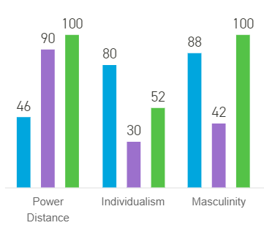

1. Power Distance

Hungary is on the lower end of the power distance spectrum. Tamás agrees with the fact that Hungary has a relatively low power distance because it is not uncommon to have a casual conversation with your boss. Romania and Slovakia score extremely high on this spectrum. Alex and Michal both agree with this because it is the norm for employees to be submissive to their bosses. There is a big power gap between people, and it is expected that people respect that hierarchical structure. For example, Alex’s grandmother will refer to the doctor as “Mister doctor” even if the doctor is younger than her because she is used to showing respect to people with important job positions. Michal also agrees because there is always a leader in his society. Indeed, the teacher are the “boss” and must be respected at all cost.

On the level of our group, we feel like there was no power distance between us. We always reached consensus on any major decision that would affect the direction of the project. There was no leader in the group, and it did not seem to bother anyone. There was higher level of respect when it came to interact with our supervisors since they are our teachers. All in all, there was no power distance between the members of the group and some power distance between the group members and the supervisors.

1. Individualism

Hungary is a highly individualist society. Tamás disagrees with this because he feels that he received a lot of help from other Hungarians, from both friends and random members of society. For example, a friend of my friend helped me get a job even though he did not know me. In this sense, Hungary is a collective society. The only part that may be perceived as individualistic is that members are expected to work hard and are held accountable for their work. On the other hand, Romania is a collective country. Alex somewhat agrees on this, because many things in Romania are done based on personal connections and having good relationships with “important” people can really make a person’s life easier. However, the country is slowly evolving towards a meritocracy. Slovakia is in the middle of the individual scale which means that the country is not inclined towards individualism nor collectivism. Michal agrees because it is quite mixed. He feels that there are people on both sides of the spectrum.

We noticed that our group encompasses both collectivist and individualistic values. The more predominant side would be collectivism because we spent a lot of in meetings dedicated to planning the future steps of our projects. We unanimously agreed that a collective approach to this project would be the best path to take because it will allow us to be on the same page which will in turn avoid redundancies in our work or, even worse, divergence in regard to the direction that each one of us went in. It might be important to mention that we still did individual work within this collectivist frame. After our meetings, we each worked on a specific topic that we had decided on beforehand. It was the sole responsibility of that member to complete his part before the next meeting.

1. Masculinity

Hungary and Slovakia are both examples of countries that have a more masculine style of motivation. Tamás agrees with this because people from his country competitively try to get a high paying job. Michal completely agrees that Slovakians are highly motivated to be the best. This approach to motivation maybe stems from the fact that a higher social status can greatly influence the quality of life of an individual in that country. In contrast, Romania is regarded as a slightly feminine country. Alex thinks that Romania should be somewhere closer to the middle. While it is true that Romanians value the enjoyment of their work, it is also true that a lot of parents put a great deal of pressure on their kids to pursue high paying or prestigious careers.

Our group is more masculine. Of course, we enjoy what we do at take a great deal of pleasure in pursuing an education in this field but have mostly been task and goal oriented when working on the Semester Project. This mindset has allowed us to achieve the results that we were hoping for within the time frame that we expected. Some of us plan on taking a feminine approach and want to dive into more details of the parts that they interesting, but only once the project is submitted.

## Group Roles

**Member Profiles**

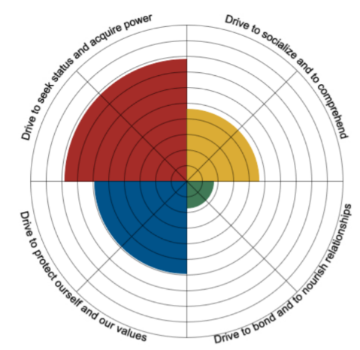The following figures show the personality profiles of the group members:

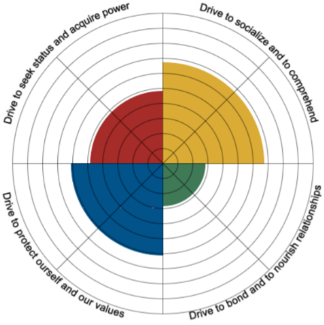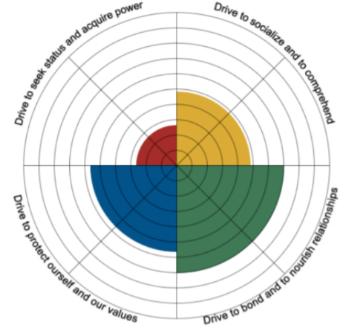

**Tamás**

**Michal**

**Alex**

* Alex – predominant red, followed by blue and yellow, with almost no green.
* Michal – predominant green, followed by blue and yellow, with little red.
* Tamás – predominant yellow, followed closely by yellow, then red and some green.

Alex has a red profile which means that he is both outgoing and goal oriented. His role in the team was making sure that the expected results were achieved properly and on time. He tried to make sure that the coding part met the criteria that the group had created in the project description.

Michal has a green profile which means that he is more people oriented. He believes in making sure that the group dynamics are good. His role in the group was to ensure stability between the members. For example, he would help the other members divide tasks so that it was fair for everyone and he would try to find compromise when there were opposing points of view.

Tamás has a yellow profile which means that he is more innovative and spontaneous. This is true because Tamás was the most creative person in the group. He would often find original ways to tackle the problem which would help the rest of the group members when they would be stuck.

Alex’s and Michal’s profile complement each other very well. They are very similar when it comes to blue and yellow, but completely opposite when it comes to red and green. Alex’s desire for results accompanied by Michal’s desire for good group stability achieves both a productive and friendly work environment. Tamás’ yellow profile adds to the group because of his ability to think outside of the box. Furthermore, his innovativeness and free spirit help the group progress in an original and creative way.

The thing that all members have in common is that they all had blue as their second most dominant color, so everyone is naturally disciplined and detail oriented. This was helpful for us to complete all the main tasks without overlooking too many details. For example, the group could spend multiple days working on the same task and would not move on until that task was completed properly. Although the group is far from being fully yellow, there was still some creative thinking involved such as the design of the Graphical User Interface. The members spent some time brainstorming different design ideas and experimenting with Balsamic.

## Project Experience Prior to Project Start

One of the factors that lead to us completing the Semester Project is our prior project experience. Michal had experience with projects because he had already completed one semester at Via University in Civil Engineering before transferring to Software Engineering. Over the course of the semester, he learned about how to cooperate with his teammates, about how to divide tasks and about the overall steps that a group goes through when doing a school project in Denmark. Tamás had experience programming in C# and C++ because he has taken a few programming classes in high school. He was equipped with the coding vocabulary and he knew how to effectively communicate his ideas about the project with the group. Alex completed his high school in Canada, so he is very used to doing group work and even group oral presentations. He already knew how to work in teams and how to stay on schedule.

# Project Initiation

## Group Formation

Our group was formed based on a controlled group formation process. The teachers have imposed a quota that limited the number of people from the same nationality to be in a group. This quota ensured that students would have to speak in English and that they would need to step out of their comfort zone. We had no constraints other than the limit of two people of the same ethnicity. We create our group based on our level of motivation, our personality compatibility and our expectations. We are satisfied with the criteria that we chose to create this group seeing that we have an exceptional group chemistry.

One thing that set us off track was the effect of the lockdown on our project planning. Everyone was destabilized by the major changes cause by the Corona Virus pandemic. We had difficulties transitioning to online work and communication was somewhat difficult in the first weeks following the lockdown. Some of us were communicating through discord and others were communicating through Facebook. This caused us to be uncoordinated and it significantly slowed our progress. We managed to solve this problem by communicating exclusively on Discord. Another problem that we encountered is that one of our members was to ill to continue the program. This meant that we had to restructure our planning to compensate for the fact that we were only three members.

## Case Presentation

The ViaFit case was presented to us by our supervisors: Allan and Mona. They showed us a transcript of an interview with Mr. SixPack. We did not have to meet with companies, nor did we choose the subject of our project. We used the information given to us by our supervisors during the presentation to write the project description.

# Project Description

The next logical step after the case presentation was to write the Project Description. We wrote a background description which consisted of looking at technology in general to introduce the topic and subsequently speak about how gyms in Denmark operate when they store their information.

Once we explained how information storing software is done in general, we define the overall problem and we ask questions about what type of information we want to store in our system and what we want to be able to do with it. In our case we wanted to store, modify and delete information about members, instructors and classes. We also wanted to extract information regarding classes and display it on a website. It is important to note that we do not mention anything about design in this phase. We used this section to identify the specific tasks that our software needed to do.

Then we defined the purpose of the project which is to create high quality, functional and reliable software that meets all the owner’s requirements in order to reduce the time it takes to find information and to avoid information from being lost. This step helped us understand why we were doing this project.

In the delimitation part we mention the things that will not be part of our project. For example, we know that we will not have a login page based on the interview transcript. We used this step to eliminate the things that we were sure we did not need.

We proceeded with the methodology part where we stipulated the steps that we should take to complete the project. We used this section to guide us all along the execution part of the project and we even used it in the Project Report. The specifics of the methodology will be explained in the Execution section of this report.

**Group work**

Once we wrote the Project Description, we needed to continue working on the project. One of the most important factors for the completion of this project was group work. It was essential that we learned to collaborate and plan our work as a team if we wanted to meet all the requirements.

We used the Group Contract as a rule guide on how to work as a team. Unfortunately, we stopped respecting the Wednesday’s weekly meeting times after the lockdown. Instead we met on days and times that were convenient for us. We started by doing voice call meetings, then we met in person because we realized that it is a much more effective strategy for us.

If a group member was not able to participate for any reason, it was expected of him to notify the group within reasonable time. We took the rule on respecting internal deadlines very seriously and luckily none of the three members slacked on their parts for the entire duration of the semester which is very impressive.

The work environment was relaxed; we brought snacks and would sometimes make jokes to cheer each other up. However, we were able to bring back our focus when we drifted to far of topic.

**Peer review**

We used the team self-evaluation checklist to review each other’s contribution to the project. These reviews were done individually so that they could be as honest as possible. Here we have the grade scale:

5: Superior – 4: Above Average – 3: Average – 2 Below Average – 1: Weak

**Alex:**

|  |  |  |  |
| --- | --- | --- | --- |
|  | **You** | **Michal** | **Tamás** |
| **Participated in discussions** | 4 | 4 | 4 |
| **Quality of contributed work** | 4 | 4 | 4 |
| **Kept project on track** | 5 | 5 | 5 |
| **Contributed with ideas** | 4 | 4 | 4 |
| **Did as agreed (Including followed the Group Contract)** | 3 | 3 | 3 |
| **Workload distribution** | 5 | 5 | 5 |
| **Total Score** | 25 | 25 | 25 |

**Michal:**

|  |  |  |  |
| --- | --- | --- | --- |
|  | **You** | **Alex** | **Tamás** |
| **Participated in discussions** | 5 | 5 | 5 |
| **Quality of contributed work** | 1 | 1 | 1 |
| **Kept project on track** | 5 | 5 | 5 |
| **Contributed with ideas** | 4 | 4 | 4 |
| **Did as agreed (Including followed the Group Contract)** | 5 | 5 | 5 |
| **Workload distribution** | 5 | 5 | 5 |
| **Total** | 25 | 25 | 25 |

**Tamás:**

|  |  |  |  |
| --- | --- | --- | --- |
|  | **You** | **Michal** | **Alex** |
| **Participated in discussions** | 4 | 4 | 4 |
| **Quality of contributed work** | 5 | 5 | 5 |
| **Kept project on track** | 3 | 3 | 3 |
| **Contributed with ideas** | 4 | 4 | 4 |
| **Did as agreed (Including followed the Group Contract)** | 3 | 3 | 3 |
| **Workload distribution** | 4 | 4 | 4 |
| **Total Score** | 23 | 23 | 23 |

We believe to have done well overall, but there is always room for improvement. Here are five actions that we could take to improve our project if we could do it again:

1. Follow the group contract better. We stopped meeting at the same time every week after lockdown started. Perhaps having a better meeting routine may have led us to be more productive over the course of the semester.
2. Spend more time on organizing our code as a group. Our understanding of how to use GitHub is mediocre at best. If we would have learned how to properly push/pull projects from the beginning, we would not have lost so much time uploading and redownloading our code on Google Drive. This is a very important aspect of group work in software engineering.
3. Have a way to urgently contact our teammates. We do not have each other’s phone number, so it is impossible to reach them if we need to urgently ask them something and they are not online.
4. Centralize all our communication on one platform instead of communicating on Facebook and Discord simultaneously. This will help us avoid misunderstandings.
5. Spend more time planning the website schedule. We should have planned the design better before doing the implementation of the schedule in order to avoid spending so much time with trial and error.

# Project Execution

The Project Execution faze is where we needed to create the actual software. It involved designing, implement and testing the software.

## Methods

We needed to design the software before coding it. We create many Unified Modeling Language diagrams. Some UML diagrams like the Class Diagram were structural, meaning they showed the structure of the system and how the different classes related to each other. Other UML diagrams such as the Use Case and Activity diagram are behavioral. They show how the user of the system can dynamically interact with system. The design aspect gives us skeleton of how the program should be coded and what the Graphical User Interface should look. Based on this, we started coding the program. We coded most the GUI and the file adapter classes simultaneously. We tested some classes individually and we also did a final test.

We initially wanted to use the waterfall method, but we ended up doing an iterative approach. The waterfall method is when we subsequently do the analysis, implementation and testing in different stages. The waterfall method was not realistic for us because we realized that there were improvements to be made in the previous stage after each time we progressed to the next stage. For example, we made changes to the design once we started coding because we noticed that our design plans might have been too ambitious. We also had to make changes to the code when the methods that we tested didn’t give us the results we expected. The iterative approach was ideal for us because it allowed improvements to constantly be made.

## Project Results

G

O

T

T

O

W

R

I

T

E

S

M

T

H

E

R

E

# Personal Reflection

## Péter, Tamás

1 page on software development

1 page on group cooperation and group dynamics

1 page of reflection relevant to this semester project

Critical decision, result, what I have learned: keep/discard next semester

## Pupák, Michal

1 page on software development

1 page on group cooperation and group dynamics

1 page of reflection relevant to this semester project

Critical decision, result, what I have learned: keep/discard next semester

## Teodosiu, Mihail Alexandru

1 page on software development

1 page on group cooperation and group dynamics

1 page of reflection relevant to this semester project

Critical decision, result, what I have learned: keep/discard next semester

# Supervision

The supervisors for our Semester Project were Mona Wendel Andersen and Allan Rune Henriksen. We handled communication with our supervisors through email and discord. Before the lockdown Mona came into the classroom on Wednesday to help us with the Project Description. Otherwise, we used her help to guide us with specific things related to properly writing reports. Allan has been extremely helpful in answering the coding questions that we asked in discord. We also solicited his help for the Use Case Diagram and the Class Diagram. Generally, the teachers gave us feedback that guided us without giving us the specific answers. Instead, they offered us options that may help us, but let us make the important decisions. Finally, the discord voice chats with both supervisors were very helpful. It would have been nice to be able to schedule in-person meetings with the supervisors, but that was impossible given the lockdown situation. We are very satisfied with the help that we got from our supervisors because they have successfully answered our questions and offered guidance that helped us advance when we were stuck.

# Conclusion

In conclusion, this semester project has taught us many things about Problem Based Learning (PBL), teamwork and software development.

PBL is a pedagogical method that focuses on the student learning from working on an open-ended problem. This approach was initially very difficult for us because we felt disoriented and we were not used to this approach. In the traditional learning methods, there is only one correct method, but with PBL there are so many different approaches that we could take and still complete the project. We quickly learned to get comfortable with this feeling of uncertainty and we knew that our supervisors would help us if we were stuck on a step or if we were going in the wrong direction. We feel like PBL has taught us how to think critically, how to be more independent learners and how to gain self confidence through trial and error.

We worked in a team of four members which unfortunately shrunk to only three members. We gained tremendous experience with group work. We needed to find a balance between collective and individual work. If all members were always working on the exact same task, it would take too much time to complete the project, but if every member was always individually working on completely different things there would be a lack of coherence between the parts that would inevitably lead to an inferior quality of our work. The strategy that we adopted was to frequently meet and plan how we would complete a specific task. Then, each member would individually work on that task while frequently updating his team. For example, we met to discuss how to code the GUI. We then each stayed in the same room to code a different part of the GUI. This method was much more efficient than all sitting behind the same computer and coding the same class all together.

On top of learning how to efficiently work as a group, we learned how plan and organize a large project. We learned that GitHub was the best way to organize our files. We also learned that setting consistent weekly meeting yielded better results than cramming work before the deadline. Finally, we noticed that online meetings were less productive than in-person meetings because it was difficult to communicate complex ideas over voice chats.

We also gained invaluable experience in Software development. In the process of searching the internet for solutions we got a wider understand on how software development works. We saw how more advanced coders organize their projects. Creating this software helped us bridge the gap between the theory from our books and the real-world application of our work.

All in all, we gained a great deal of knowledge that will help us in our future programming endeavors. Our takeaways for the next semester project is to use Git Hub, to not neglect the importance of organizing our folders, to spend a lot of time communicating with our group colleagues and to steadily and consistently work on the project.